Formik and Yup in React application

Objectives and Outcomes
In this exercise you will learn to use Form validation by Formik. You will install and configure Formik, Yup and use it within your React application. At the end of this exercise, you will be able to:
- Install and configure Formik, Yup within your React application

Install and Configure Formik, Yup
- As a first step you will create a new React application. Then install Formik and Yup into your application as follows:
npx create-react-app ReactForm
npm install formik yup
Your package.json file like:
"formik": "^2.2.9",
"yup": "^0.32.11" ,

Create Contact components for display the view
- Create the Contact component (named Contact.js) to add the new contact by yourself (use Materialize, Material UI or some libraries which support Material design), the screen display as follow:
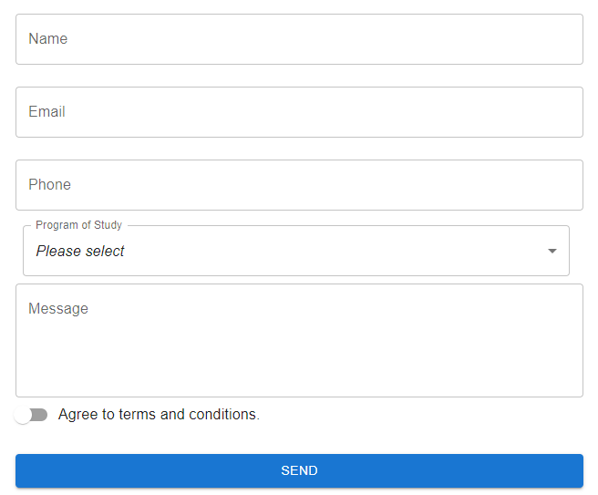

Import useFormik and create initial values
- Open the Contact.js file, import useFormik and write codes as follow:
…
import { useFormik } from 'formik';
…
const formik = useFormik({
initialValues:{
name:"",
email:"",
phone:"",
program:0,
message:"",
agree:false
},
});

Update the initial values and get the values of controls (textbox, select,…)
<form onSubmit={formik.handleSubmit}>
<TextField
label="Name"
name="name"
value={formik.values.name}
onChange={formik.handleChange}
/>
<TextField
label="Email"
name="email"
value={formik.values.email}
onChange={formik.handleChange}
/>
<TextField
label="phone"
name="Phone"
value={formik.values.phone}
onChange={formik.handleChange}
/>
<FormControl sx={{ m: 1, minWidth: 600 }}>
<InputLabel id="demo-simple-select-autowidth-label">Program of Study</InputLabel>
<Select
labelId="demo-simple-select-autowidth-label"
id="demo-simple-select-autowidth"
label="Program of Stydy"
name="program"
value={formik.values.program}
onChange={formik.handleChange}
>
<MenuItem value={0}>
<em>Please select</em>
</MenuItem>
<MenuItem value={1}>Software Engineering</MenuItem>
<MenuItem value={2}>Information System</MenuItem>
<MenuItem value={3}>Information Assurance</MenuItem>
<MenuItem value={4}>Internet of Things</MenuItem>
<MenuItem value={5}>Artificial Intelligence</MenuItem>
<MenuItem value={6}>Digital Art & Design</MenuItem>
</Select>
</FormControl>
<TextField
id="outlined-multiline-static"
label="Message"
multiline
name='message'
rows={4}
value={formik.values.message}
onChange={formik.handleChange}
/>
<FormControlLabel control={<Switch/>} label="Agree to terms and conditions." name='agree'
value={formik.values.agree} onClick={formik.handleChange} />
<Button
type='submit'>
Send
</Button>
</form>

Validate to form values by Yup
- Next, we need to import the Yup to validate the values of form.
- Write codes as follow:
….
import * as Yup from 'yup';
…
const formik = useFormik({
initialValues:{
name:"",
email:"",
phone:"",
program:0,
message:"",
agree:false

},
onSubmit: (values)=>{

},
validationSchema: Yup.object({
name: Yup.string().required("Required.").min(2, "Must be 2 characters or more"),
email: Yup.string().required("Required.").email("Invalid email"),
phone: Yup.number().integer().typeError("Please enter a valid number"),
program: Yup.number().integer().typeError("Please select a program."),
message: Yup.string().required("Required.").min(10, "Must be 10 characters or more"),
agree: Yup.boolean().oneOf([true], "The terms and conditions must be accepted.")
}),

});

Show the errors of control values
- Update codes as follow:
. . .
<Textfield
name="name"
. . .
/>
{formik.errors.name && (<Typography variant="caption" color="red">{formik.errors.name}</Typography>)}

<Textfield
name="email"
. . .
/>
{formik.errors.email && (<Typography variant="caption" color="red">{formik.errors.email}</Typography>)}

<Textfield
name="phone"
. . .
/>
{formik.errors.phone && (<Typography variant="caption" color="red">{formik.errors.phone}</Typography>)}
<select
name="program"
>
. . .
</select>
{formik.errors.program && (<Typography variant="caption" color="red">{formik.errors.program}</Typography>)}
<TextField
name='message'
...
/>
{formik.errors.message && (<Typography variant="caption" color="red">{formik.errors.message}</Typography>)}
<FormControlLabel control={<Switch/>} label="Agree to terms and conditions." name='agree' value={formik.values.agree} onClick={formik.handleChange}/>
{formik.errors.agree && (<Typography variant="caption" color="red">{formik.errors.agree}</Typography>)}

- Submit form when all data had validated:
onSubmit: (values)=>{alert(JSON.stringify(formik.values))},
//Convert to JSON string and show in alert box.

Run your React app and see the result

Conclusions
In this exercise you learnt to use Formik and Yup in React application.

